**Images**

**Adding Images Using the <img> Element:**

Images are added to a site using the <img> element, which has to carry at least two attributes: thesrc attribute, indicating the source of the image, and an alt attribute, which provides a description of the image.

Example:

<img src = ”a.jpg” alt=”photo” />

**Attributes:**

1. **The src Attribute:**

* The src attribute tells the browser where to find the image. Generally speaking, images for your site should always reside on your server. It is not good practice to link to images on other sites because if the owner of the other site decides to move that image, your users will no longer be able to see the image. Since the images are on your server, rather than being an absolute URL, the value is more likely to be a relative URL that uses the same shorthand notations.

Example:

<img src = ”logo.gif” />

1. **The alt attribute:**

* The alt attribute must appear on every < img > element and its value should be a text description of the image.

Example:

<img src = ”logo.gif” alt = ”Wrox logo” / >

* Often referred to as *alt text* , it is important that the value of this attribute really describe the image.

1. **The height and width Attributes:**

* The height and width attributes specify the height and width of the image, and the values for these attributes are almost always shown in pixels

Example:

<img src=”logo.gif” alt=”Wrox Logo” height=”120” width=”180” / >

1. **The align Attribute:**

The align attribute was created to align an image within the page (or if the image is inside an element that is smaller than the full page, it aligns the image within that element).

Example:

<img src=”images/cover.gif” alt=”Book cover” align=”left” />

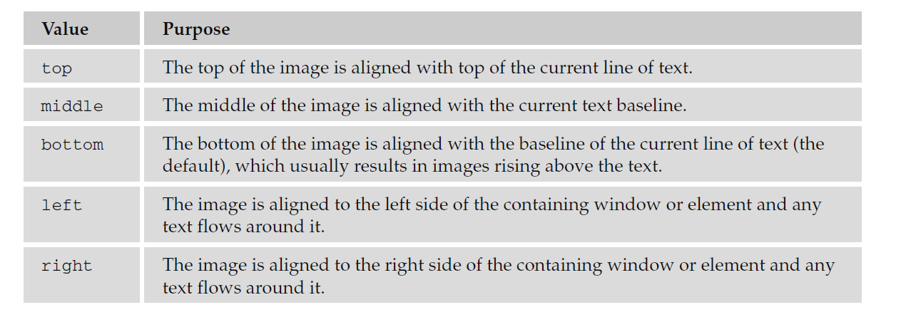

1. **The ismap Attribute:**

The ismap attribute is a boolean attribute. When present, it specifies that the image is part of a **server-side image-map** (an image-map is an image with clickable areas). When clicking on a server-side image-map, the click coordinates are sent to the server as a URL query string.

**Note:** The ismap attribute is allowed only if the <img> element is a descendant of an <a> element with a valid href attribute.

1. **The usemap Attribute:**

The usemap attribute specifies an image (or an object) as a **client-side image-map** (an image-map is an image with clickable areas). The usemap attribute is associated with a <map> element's name or id attribute, and creates a relationship between the <img> and the <map>.

**Note:** The usemap attribute cannot be used if the <img> element is a descendant of an <a> or <button> element.

1. **The longdesc Attribute:**

The longdesc attribute specifies a hyperlink to a detailed description of an image.

Example:

<img longdesc = “string”>

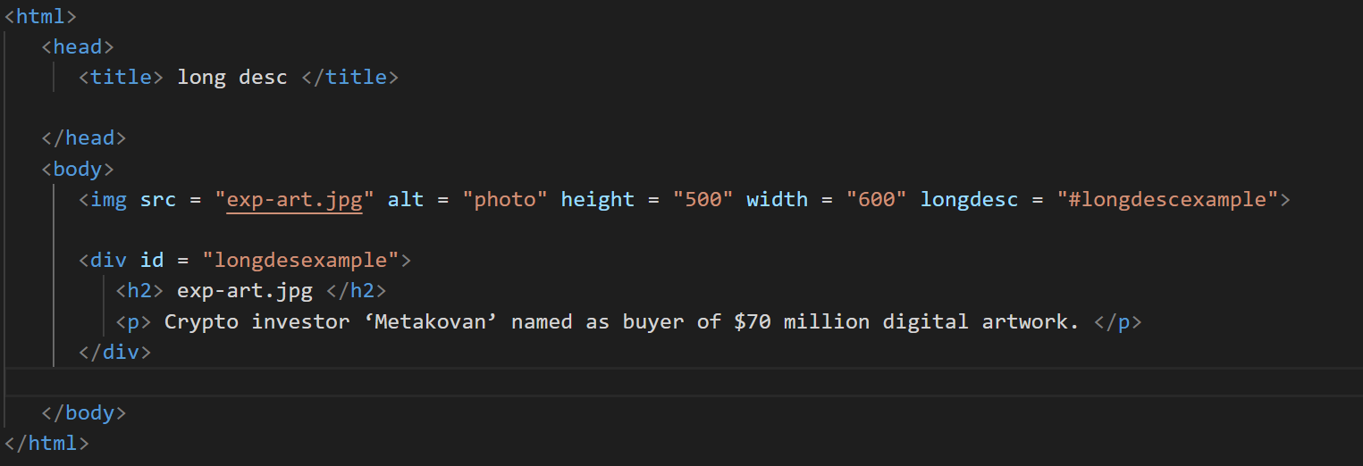Source Code:

**<scroll more>**

Output:

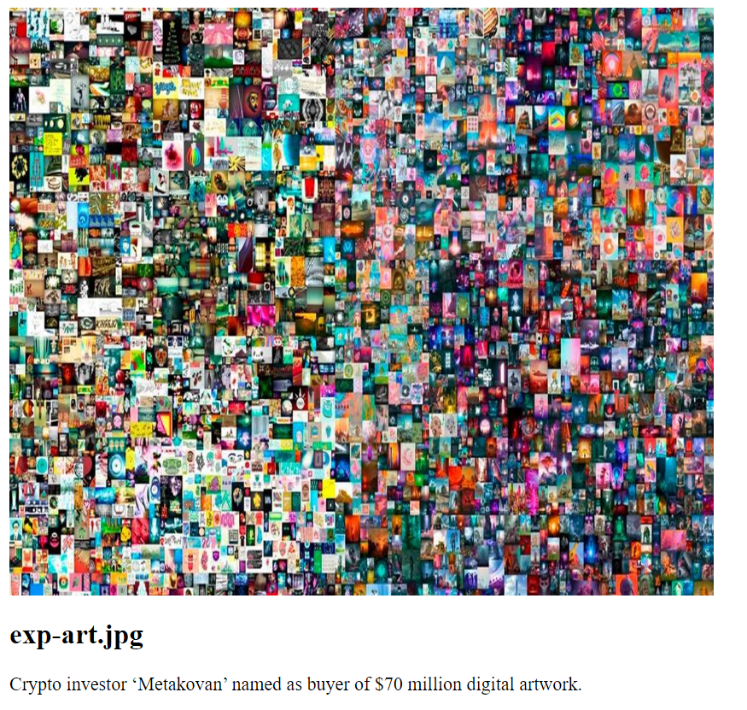

**Keeping File Sizes Small:**

You will usually want to save the images for your site in the format that best compresses the image and therefore, results in a smaller file size. Not only will your pages load faster, but you can save on the charges (or fee) to host your site.

Usually, one or another format will be the obvious choice for you. The rule of thumb is:

* Use JPEGs for photo - realistic pictures with a lot of detail, or subtle shade differences you want to preserve.
* Use GIFs or PNGs for images with flat color (rather than textured colors), and hard edges, such as diagrams, text, or logos.